Covid-19 tracker

Author Samuel Ojala

# Description of the application

The application allows the user to see the number of covid-19 cases, deaths and tests, as well as the current population, in a chosen hospital district during a chosen week.

-There are two spinners from where the user can choose a hospital district and a week, this allows the program to search and display the desired information.

-There are two buttons that make a search using the spinners. Home search is shown in the upper display and is done based on the chosen hospital district and the latest week that has any data recorded. This button is a checkbox that can be unchecked to remove the displayed data or left checked which will make the program redo the search when opening the application again. The other button makes a search based on both of the spinners and is shown in the lower display.

-Every search is saved into a log which can be viewed in another view through a button in the main screen, this allows the user to see what they have searched and when.

# The implementation

The program is built in android studio using solely tools found in it.

Libraries used:

-Json libraries, exception handling libraries.

-Url, BufferedReader and InputStream for reading data from an url.

-checkbox, textview and spinner for interface elements.

-Intent, bundle, Activity and SharedPreferences for saving and moving data.

-Arraylist to store the log.

-View to get the users button clicks.

Implemented the mandatory features, should get 13 points

Application is build from well designed UI-components 1-5p

# Class diagram

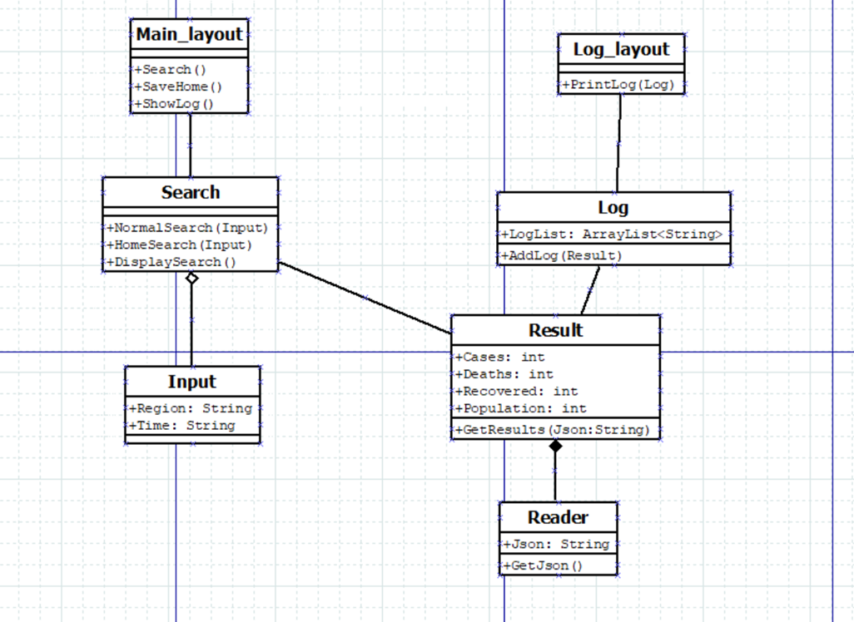

# Workloads

| **Tasks** | **Hours** |
| --- | --- |
| Development, testing | 70+ :( |
| Commenting, cleanup | 5 |
| Design | 5 |
|  | 80 |

# What did I learn from the project?

I learnt:

-how to use an api

-onResume/onPause or how to retain data in an application

-how to make and utilize components like spinner, checkbox, textbox, etc

-xml basics

-how to use basic features of Android studio

-Alot about how to interpret error messages!

-to never do group projects alone